**SMART CREDIT: MAXIMIZING YOUR FINANCES**

Arvind Haridas

02/09/2024

*Abstract*

This project proposes an intermediary application for connecting banking institutions and potential credit card users. Its primary goal is to utilize machine learning techniques to provide consumers with the ideal credit card and ideal banking institution for their purposes.

It achieves this by using existing credit card users and their personal expense profiles to build a classification model, which in turn can be used to identify the best options for both existing users without credit cards and entirely new customers based on their respective expense profiles. By providing this service across multiple banking institutions, it will ensure that customers are always receiving the maximum benefit.

1. **Problem Statement**

Over the last decade, India has seen the steady expansion of cashless transaction forms across the entire population. Where handling physical currency used to be a necessary evil, technological developments have opened up avenues for businesses and customers to transact directly. In the wake of the rapid expansion in access to the internet, banking institutions now provide the means for even small businesses to offer EFTPOS services. The ubiquity of smartphones has also resulted in the proliferation of e-wallets, enabled by the creation of the UPI system in 2016.

The convenience of having access to ones finances without having a physical burden attached to it is naturally very appealing to the consumer. Handling physical currency is a massive inconvenience and poses a security concern that is very hard to mitigate. Cashless transaction services provide the means for the consumer to access the full extent of their funds, while still keeping said funds secure. The COVID pandemic has also caused a shift in perspective, due to the fears of infection via virus contaminated currency.

Unfortunately, the rollout of such transaction forms has been very haphazard, resulting in numerous holes in their actual spread across the broader Indian populace. One of the most significant shortfalls is in the market penetration of credit cards, where India disproportionately lags behind western nations relative to other cashless transaction forms. In situations where the use of credit cards are ideal as demonstrated in more developed markets, consumers in India resort to less useful e-wallets or cash.

These shortfalls mostly manifest in the execution of the business relationship between banking institutions and the consumer. Credit card services themselves are not structured optimally, and even the suboptimal choices are not presented well to the consumer. The goal of Smart Credit is to act as a supporting intermediary in that relationship, by solving or bypassing the shortfalls and enabling the expansion of such relationships.

1. **Market/Customer/Business Needs Assessment**

**2.1 Market Features**

1. **Underutilization of credit cards**: As of June 2023, credit card penetration has only reached an estimated 5.5% of the population. In developed western nations, this number can reach 60-80%, indicating that there is significant opportunity for growth in this sector in India.
2. **Lack of variety in dominant banking institutions**: The Indian banking sector is dominated by a few major companies, with few opportunities for smaller institutions to differentiate themselves from their counterparts.
3. **Growing demand for cashless transactions**: Both e-wallets and credit cards are increasing in popularity, driven by government policies such as the demonetization, external pressures such as the COVID pandemic and by an increasingly tech-savvy consumer base.
4. **Poorly designed credit card services**: Credit cards are largely marketed as an extraneous addition to the banking experience, rather than as a core feature.
5. **Alternatives already entrenched in the market**: E-wallets are disproportionately more popular than credit cards, including in use cases that typically favour the latter.

**2.2 Customer Behaviour and Needs**

**2.2.1 Consumer Needs**

1. **Targeted marketing**: Consumers are unlikely to go for services which aren’t presented directly to them; they must be shown to the market proactively.
2. **Awareness of the benefits of credit cards**: Consumers need to be made aware of how credit cards benefit them, with particular emphasis on how each type benefits them personally and specifically.
3. **Access to the entire market**: Consumers need to know the entire wealth of options available to them, across all suitable banking institutions.

**2.2.2 Banking Institution Needs**

1. **Access to broader new consumer base**: Consumers exhibit loyalty to one institution out of convenience; other institutions need an intermediary who can link them with new clients without being rejected immediately.
2. **Appeal to existing clients**: Banking institutions need to put credit cards as a core component of their banking experience. This requires them to be able to appeal to existing clients in an effective manner.
3. **Awareness of market:** Due to the unpopularity of credit cards and the poor design of their services across the industry, it is hard for banking institutions to make educated decisions in this sector; an intermediary with a presence across the industry is in a position to provide qualified professional insight.

**2.2 Business Needs**

1. **Presence across the banking industry:** In order to meet the needs of the consumer and banking institutions, we need to have a presence across all major banking institutions. The value in our product reduces dramatically if we are limited to only a subset of institutions.
2. **Consumer-centric design:** Existing conditions are biased against consumer engagement; the product needs to cater to them specifically as the bulk of opportunities lies in leveraging new customers.
3. **Collaborate relationship with banking institutions:** Revenue as well as opportunities benefit from a cooperative relationship with banking institutions, so there is a need to establish a strong, mutually-beneficial relationship with them.
4. **Target Specification**

**3.1 Core Functionality and Design**

1. **Personalized Expense Tracking:** Consumers who obtain the app directly (as opposite to via their bank) should be able to input and track their expenses. Using ML techniques, we can classify them based on their expense profile and recommend their ideal banking institution and credit card type.
2. **Intuitive UI:** In order to appeal to consumers across the entire spectrum of comfort with technology, it is important that the UI is as intuitive as possible.
3. **Credit Card Market Access:** Consumers should be able to see all the credit cards available across all noteworthy banking institutions.

**3.1 Performance and Technical Requirements**

1. **Security:** The expenses data needs to be encrypted to ensure that the privacy of the consumer is respected.
2. **Performance:** The application needs to be smooth and performant enough to ensure that the expense tracking is not a hassle.
3. **Scalability:** The application needs to be able to maintain its performance as the number of consumers and partnered banking institutions grows.
4. **Benchmarking**

Currently, there are no direct competitors to this product as a whole. Only partial competitors exist, in the form of individual banking institutions having sections of their apps/websites for consumers that approach the institution. There is little to no personalized advice offered to clients, with the various credit cards simply being offered at face value. Consumer awareness is only partially satisfied, since each institution only shows the cards that they offer. There is little to no proactive marketing of their services.

1. **Applicable Regulations**

There exists a handful of legislative acts that are of pertinence to this application:

**5.1 Information Technology Act, 2000**

The IT Act is the principal statue covering laws on technology. It sets the groundwork for the permissions with regards to record keeping, data disclosure for law enforcement and data confidentiality. Subsequent legislation is made under the ambit of the IT Act.

**5.2 Digital Personal Data Protection Act, 2023**

The DPDA act is the latest standard that delineates our obligations as data fiduciaries on data processing, as well as the rights and obligations of those whose data we are collecting and using.

1. **Applicable Constraints**

**6.1 Financial Constraints**

The biggest financial constraints to this application will be at the outset. Developing the application will naturally carry an up-front cost. Initial revenue streams will be constrained while we establish connections with banking institutions, since our product quality is dependent on our ability to present consumers with the credit card services from multiple banking institutions.

Depending on how the product launch progresses, we may also need to allocate some budget to marketing in case we cannot reach a sufficiently broad audience organically.

**6.2 Expertise Constraints**

Due to the variety in technical expertise among the consumers, we need a highly skilled development team in order to build an application that is truly intuitive. This requires a deep awareness of modern UI/UX standards from the development team.

**6.3 Space Constraints**

This project doesn’t necessitate any physical presence to the consumer/banking institution. However, building the ML models required for classifying consumers will naturally require processing power. If the performance demands are consistent and significant enough, then we can set up our own physical servers for this purpose. We also have the option of settling for cloud computing services if convenience is the bigger priority.

**6.4 Time Constraints**

Given the fact that this project is dealing with an entirely unoccupied role in the banking industry, it is of paramount importance that the project is executed as soon as possible. Being the first company to venture into this space would be a massive advantage for the long-term potential of this application.

**6.5 Regulatory Constraints**

Institutions may have differing levels of data sharing consent standards for their existing clients. Work-arounds may be necessary on a case-by-case basis, and we need the necessary flexibility in our modelling process to account for that.

Owing to the recent and significant change in the legal setting due to the passing of the DPDA Act, specific attention also needs to be paid to regulatory adherence. The aforementioned need for technical expertise opens the risk of outdated preconceptions among the experienced members, which mandates a careful balancing act between legal safety and timely development.

1. **Business Model**

**7.1 Primary Income**

1. **Referral commission**: We would receive a commission from the banking institution for every new customer directed to said institution’s credit card schemes
2. **Integration commission:** We would receive a commission from the banking institution for every existing customer that is directed to a credit card that is better suited
3. **Consulting fees:** We would provide consulting services to our partnered banking institutions. This will come in the form of analysing the specific institution’s data itself for unrealized opportunities, as well as in the form of providing our unique perspective of the broader credit card industry.

**7.2 Secondary Income**

1. **Advertisements:** We can anticipate that even non-credit card users would gravitate towards our application for expenses tracking. Including advertisements in the application lets us monetize this feature.
2. **Concept Development**

The development of this application into its full-fledged form will necessarily follow certain phases:

**8.1 Exhibition Prototype**

We will first develop a prototype of the application that is complete at a visible level. The goal here is to have something that appears to be an end product for the purpose of initial marketing, so that time isn’t wasted on aspects that aren’t necessary yet.

**8.2 Canvassing of institutions**

Using the prototype as a demonstrator, we will establish partnerships with banking institutions. Since we require multiple such partnerships before our product becomes launch-worthy, this provides time for the development to complete.

**8.3 Deployment within institutional consumer bases**

Using the data of existing bank clients acquired via our partnerships, we can build our ML model of client classes and start to provide our services within institutional boundaries. We can use our association with the banking institutions to market directly to their clients, which provides a more effective way of increasing our user base.

**8.4 Deployment to broader public**

Once we have reasonable coverage of the major banking institutions, we can make the application available to the broader public. Our models should be near-optimal by this point, and the existing user bases cultivated in the earlier phase should help with the propagation of the application.

\

1. **Final Product Prototype**

The final SMART CREDIT application aims to be the main intermediary for credit card users between them and their banking institutions. It will arm users with the knowledge required to maximize the returns from their hard-earned wealth. The integration of an expenses tracker also serves to attract even those without an immediate interest in getting a credit card.

Banking institutions will benefit from an intermediary who can help the institution make better educated decisions in targeted marking and expansion, as well as provide a beneficial service to existing clients.

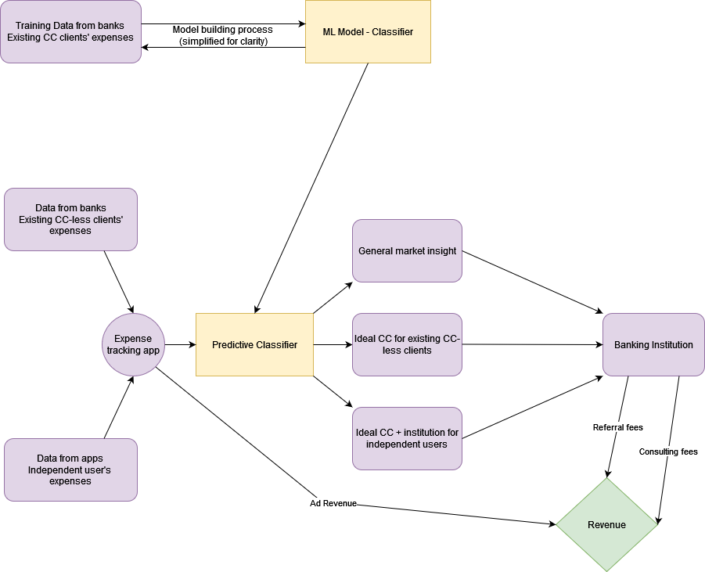

1. **Product Details**

**10.1 How does it work?**

The product can be divided into three parts, two of which are visible parts of the application.

**10.1.1 Expenses tracking**

This part of the application is a basic data logger that deals with letting the user track his various expenses. The categories that the tracker allows will be tailored to match the various specializations that credit cards can favour (eg. Travel, e-commerce, etc). We will also add some forms of data visualization. While users can opt to use just this part, this serves to get our foot in the door to offer the ideal credit card for them based on their expenses profile.

**10.1.2 Credit card market**

This part of the application displays all the various credit cart types with its benefits across all partnered banking institutions. Using the data from the expenses tracking and our ML classifier, we will identify their ideal credit card and refer the user to the banking institution offering said credit card.

**10.1.3 Consulting services**

The data collected from the aforementioned two processes, combined with data obtained from the banks directly, will give us a uniquely broad perspective of the market, which we will provide to partnered institutions in the form of consulting services.

**10.2 Data Sources**

1. Our first batch of data comes from existing CC clients from partnered banks. This will be used to build our classifier.
2. Banks will subsequently provide us data about CC-less clients to run our classifier on, and target those clients based on our results. We will use the data from the success of that targeted marketing to improve the classifier further.
3. Finally, when the application is opened to the broader public, the expenses inputted into the application by independent users will also be used.

**10.3 Frameworks/Algorithms/Software used**

1. **ML Classification techniques:** This will be used to classify based on the expenses
2. **Database management system:** This will be used to manage the expenses data obtained from the banks and the independent users.
3. **Software for app development:** We will need to develop apps for both Apple and Android, and will need their respective dev tools.

**10.4 Required team to develop**

1. **ML engineers:** They will be required to develop and optimize the classification model.
2. **Database admin:** They will be required to maintain the database and ensure that legal regulations are being followed for data security.
3. **Software developers:** They will be needed to develop the application.
4. **Business relation experts:** They will be needed to build the crucial links with banking institutions required for this project to get off the ground.
5. **Conclusion**

Overall, Smart Credit can establish itself as the torch bearer for the credit card industry in India. By acting as an intermediary between consumers and banking institutions, it can take a dominant role in shaping credit card services into an effective tool for personal transactions, to the benefit of both banking institutions and consumers. Through the use of ML techniques from the outset, it can ensure that it stays at the forefront of technological capability on this front.

Project 3

Prototype Development and Business Modelling

# Prototype Selection

In order to assess this concept, we need to look at the short-term and long-term potential of the project and how it can be monetized

## Feasibility

The core of the project can be developed in at most 1 to 2 years. The ML concepts that are to be used are popular and well-understood algorithms, so applying them effectively should not be difficult. The general programming requirements are also achievable in a reasonable period of time, since there aren’t any excessively complex components involved in it.

A more crucial side of the project is establishing tie-ups with banking institutions. The effective value of our product increases dramatically as our network increases. Establishing a broad network will take 2 years.

## Viability

The project is certainly viable in the very long term. Modern social progress has seen an incessant swing towards cashless transactions, so there will always be some customer base for the product to apply to. The only noteworthy concern is the slowing down of growth as Indian customer bases catch up, but that is sufficiently far into the future that we can formulate plans to deal with it once our product is established.

## Monetization

The manner in which we monetize the product is highly flexible, since we possess multiple monetization avenues. If we focus on direct monetization, these are the avenues that we can explore:

1. **Ideal CC for existing CC-less customers**: Per-customer fee from customer’s banking institution
2. **Consulting Services for General Market Insight**: Annual subscription fee from banking institution

# Prototype Development

It is not possible to develop a full-fledged prototype. Data from banking institutions is naturally held to high security standards and is not released to the public. Obtaining data from clients can only happen once the client-side app is developed, and requires a level of standardization and detail that cannot be found from publicly available sources.

# Business Modelling

The two avenues for direct monetization are best exploited using a combination of a subscription and a consulting business model.

### Ideal CC for existing CC-less customers

Finding the ideal CC for a customer is a task that is repeated on a per-customer basis. Offering this under the regular subscription service wouldn’t work, since this task scales with the size of the customer base. Therefore, this will be monetized by charging the banking institution a fee on a per-customer basis.

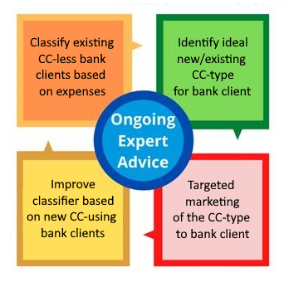

### General Market Insight

It is best to provide the general market insight service as an annual subscription service. Since the credit card industry in India is still in its nascent stages, we can anticipate that there will be significant changes in the market landscape with time. This makes a subscription service a very valuable proposition for the banking institution, since it allows them to keep track of the changes as they happen.

The annual scheme is chosen because it suits the needs of both our business as well as the banking institution. Since banks are not very quick to respond to market conditions (due to industry constraints like security), a larger timeframe for our service would fit the timeframe of their projects. It also provides us with a level of security in revenue streams, where a shorter timeframe may cause cashflow issues if customers drop out. Since the quality of our models increases with more partnered banking institutions, said institutions are incentivized to keep up their subscriptions to our service.

Initial market entry in this regard may be difficult, since our ability to provide insight is at its lowest when we are yet to build up knowledge from data obtained from clients as part of our other associated services. Therefore, it may be prudent to offer a limited free tier for this service, especially if the beneficiary of the service is already paying us for other services.

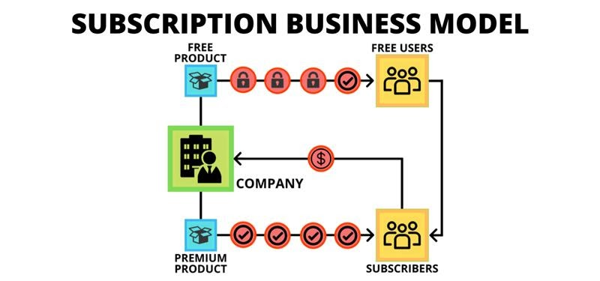

# Financial Modelling

Out of the two directly monetizable services under discussion here, only the task of finding the ideal CC for existing CC-less customers can be estimated. The quality of the market insights that we can sell as a subscription service is always growing and is dependent on the performance of our other services, so we cannot attach a singular value to it at this stage. The returns from how we sell our general market insight is heavily dependent on sales personnel quality as well.

## Ideal CC for existing CC-less customers

5.5% of the adult population has currently got credit cards, where developed nations have a proportion of 60-80%. For the purpose of financial calculations here, we can take 60% as a conservative estimate for our targets.

Approximately 78% of the adult population of India has got a bank account, so we can assume that approximately 47% of the adult population are potential credit card users (in context of how we are developing our service), out of which 44.5% are currently CC-less.

India has an adult population of 970 million, giving us a long-term target base of 430 million. It is difficult to make predictions beyond this point. Between factors such as the size of our banking institution network, growth in the average wages and technological development, it is hard to comment on the nature of our expansion as the credit card user base reaches this long-term target base. What can be said with certainty is that a sustainable initial model can be sustained in the extreme long-term as well.

We can estimate our short term sustainability. Let A be amount we charge the banking institution for the classification of one customer. Let B be the cost of running that classification for us. Let C be the running costs of the project, i.e. wages for the team. Let N be the number of classifications we do per month.

$$Profit=N\left(A-B\right)-C$$

If we take a team of one ML engineer (15 lpa), one data engineer (15 lpa) and one industry expert for networking (30 lpa), this gives us C = 5 lakhs. We therefore break even when $N\left(A-B\right)>5$ lakhs, which is definitely achievable at the outset. These values will naturally change as our service grows larger and more popular.